**CHAPTER 1**

# INTRODUCTION

In the modern digital era, artificial intelligence (AI) has profoundly transformed our interaction with technology. Among the various applications of AI, chatbots have emerged as highly impactful tools, acting as intelligent virtual assistants capable of handling diverse tasks. This mini-project, titled AI Chatbot for the Department of Artificial Intelligence & Data Science, explores the design, and implementation of an AI-powered chatbot aimed at enhancing user experience within the Department of AI & DS at KS School of Engineering and Management.

## 1.1 Background of AI Chatbot

A chatbot is a computer program designed to simulate conversation with human users, either through text or voice interactions. Our mini project aims to create a basic chatbot AI that can engage in natural-sounding conversations. The project seeks to develop a chatbot that can understand and respond to user input in a conversational manner, simulating human-like interactions. The chatbot will be able to interpret user messages and generate relevant responses.

The project will focus on developing a text-based chatbot, with a user-friendly interface that allows users to interact with the chatbot using everyday language. As the project progresses, the chatbot's capabilities can be expanded to include more advanced features such as voice-based interactions, emotional intelligence, and multi-language support.

## 1.2 Problem Statement

The problem statement for the AI chatbot mini project is to design and develop a conversational AI that can effectively understand and respond to user input in a natural and intuitive manner. Currently, many chatbots struggle to comprehend the nuances of human language, leading to frustrating user experiences and limited functionality. The challenge lies in creating a chatbot that can accurately interpret user intent, context, and emotions, and respond accordingly.

The majority of chatbots are not designed to handle complex or multi-step conversations, leading to a lack of depth and personalization in user interactions. Additionally, many chatbots fail to provide a seamless and integrated user experience, often requiring users to navigate multiple interfaces and platforms. The goal of this project is to address these limitations by developing a chatbot that can learn from user interactions, adapt to different contexts and emotions, and provide a personalized and engaging user experience. The project aims to create a chatbot that can revolutionize the way humans interact with technology, making it more intuitive, accessible, and enjoyable.

## 1.3 Objectives of Chatbot

A chatbot integrated into a department website can serve several key objectives:

1. **Enhance User Experience:** Provide 24/7 support for inquiries about programs, events, and department facilities. Offer quick responses to common questions, reducing wait times and improving user satisfaction.

1. **Improve Information Accessibility:** Help users navigate the website efficiently by directing them to relevant pages and resources. Provide instant access to frequently asked questions and important updates.

1. **Increase Engagement and Interaction:** Engage with prospective and current students through interactive content and personalized recommendations. Collect feedback from users to improve services and address concerns promptly.

1. **Support Academic and Student Services:** Offer academic assistance by answering queries related to courses, schedules, and academic policies. Provide information about student services, including counselling, career services, and extracurricular activities.

1. **Data Collection and Analytics:** Gather data on user interactions to identify common issues and areas for improvement. Use analytics to understand user behaviour and preferences, helping to tailor future communication and services.

1. **Cost Efficiency:** Reduce the need for extensive human support staff, lowering operational costs. Automate repetitive tasks, allowing staff to focus on more complex and value-added activities.

1. **Promote Inclusivity:** Support multiple languages to cater to a diverse student body. Provide accessible support for students with disabilities by offering voice and text-based interaction options.

**1.4 Scope of the project**

The scope of the mini project chatbot AI encompasses the design, development, and testing of a conversational AI that can understand and respond to user input in a natural and intuitive manner. The project will focus on creating a text-based chatbot that can engage in basic conversations to interpret user intent and generate relevant responses. The chatbot will be designed to be task-oriented, capable of completing specific tasks such as answering frequently asked questions, providing information, or assisting with simple transactions.

* Design and develop a conversational AI chatbot.
* Design a user-friendly interface for chatbot interaction.
* Test and refine the chatbot with user interactions.
* Evaluate chatbot performance using relevant metrics (accuracy, precision, user satisfaction).
* Develop a functional prototype with a focus on future expansion and improvement.

## Limitations of the project

* Chatbots may struggle with understanding complex language, especially if they are not trained on specific domain or terminology used within the department.
* Maintaining context over a conversation can be challenging. Chatbots may not always remember previous interactions or understand changes in conversation direction.
* Accuracy in providing relevant information depends heavily on the quality of the training data and the algorithms used.
* Chatbots may struggle with handling complex queries that require nuanced understanding or decision-making based on multiple factors.
* Integrating the chatbot with backend systems (like databases or APIs) to fetch real-time information can be complex and may require additional development effort.
* Managing user expectations about what the chatbot can and cannot do is important to avoid disappointment and dissatisfaction.

**CHAPTER 2**

# LITERATURE REVIEW

The rapid advancements in artificial intelligence (AI) and natural language processing (NLP) have significantly transformed the way humans interact with machines. One of the most notable applications of these technologies is the development of AI chatbots, which simulate human conversation and provide automated assistance across various domains. AI chatbots have evolved from simple rule-based systems to sophisticated models capable of understanding and generating human-like responses.

This literature review explores the key developments, methodologies, and applications of AI chatbots. It examines the transition from early rule-based systems to modern AIdriven chatbots, highlighting the role of machine learning algorithms, neural networks, and large language models in enhancing chatbot capabilities. Additionally, it discusses the various use cases of AI chatbots in customer service, healthcare, education, and other sectors, emphasizing their potential to improve efficiency, accessibility, and user experience.

**1. Literature Survey on College Information Chatbot:**

**Author Name:** Sri Varshini K, Shilpa Shri R, Anusha U A

**Year of Publication:** 2024

**Abstract:** A chatbot is software that allows users to communicate with computers in natural language, similar to human conversations. Chatbots interact with clients and provide answers based on human input. The user may believe they are conversing with a human, while in reality, they are interacting with a machine. The chat bot program enables students to inquire about college admissions from any location with an internet connection and receive prompt responses.

**Conclusion:** The college chatbot literature survey highlights their transformative potential in enhancing user experiences and streamlining administrative processes in education. Advanced technologies, including natural language processing and sentiment analysis, contribute to intelligent and context-aware interactions. The surveyed papers underscore pragmatic applications of chatbots in alleviating administrative burdens.

**2. A Literature Review on chatbots in education: An intelligent chat agent:**

**Author Name:** Gil Maria dos Santos Romao

**Year of Publication:** 2021

**Abstract:** The class size in a university often impacts on how an educator delivers the material, and how students interact in the class. Small class size often allows students and educators to interact and have a more positive rapport. Class size in many universities are quite large. This places an additional workload on the lecturer, and makes fostering this interaction more difficult.

**Conclusion:** The review ends with the conclusion which looks at the research questions and the aim, and summarizes the found answers and the key points of the discussion. The aim of the research was to further the development of educational chatbots by reviewing what had been done and summarize this knowledge.

**3. A review of their potential applications in library services:**

**Author Name:** Sankhayan Mukherjee, Swapan Kumar Patra

**Year of Publication:** 2023

**Abstract:** Chatbots are increasingly getting popularity in recent years. It is being predicted that this new technology is going to affect all aspect of human being. Along with its applications in other areas it can also be widely used in the field of Library and Information Science (LIS). In this context this study is an attempt to survey a few available Chatbots globally.

**Conclusion:** The use of Chatbots may usher a new paradigm in LIS systems and services. There are currently very limited studies on the utilization of Chatbots in LIS field. This study is a brief survey of major Chatbots and offers a preliminary but much needed understanding of the driving forces behind the use of conversational interfaces. Although Chatbots could be very valuable tools for LIS profession but they could not replace librarians

**4. A Literature Survey of Recent Advances in Chatbots:**

**Author Name:** Guendalina Caldarini, sardar Jaf, Kenneth McGarry

**Year of Publication:** 2022

**Abstract:** Chatbots are intelligent conversational computer systems designed to mimic human conversation to enable automated online guidance and support. The increased benefits of chatbots led to their wide adoption by many industries in order to provide virtual assistance to customers. Chatbots utilize methods and algorithms from two Artificial Intelligence domains: Natural Language Processing and Machine Learning.

**Conclusion:** In this paper we a survey of relevant works of literature on the subject and analyzed the state of the art in terms of language models, applications, datasets used, and evaluation frameworks. Despite technological advancements, AI chatbots are still unable to simulate human speech. This is due to a faulty approach to dialogue modelling and a lack of domain-specific data with open access.

## 5. Literature Review on Implementation of Chatbots for Commerce Use

**Author Name:** Williams Sanjaya, Calvin, Rafif Muhammad, Meiliana, Muhamad Fajar **Year of Publication:** 2023

**Abstract**: The technological advancements in Chatbots itself have made chatbots more humanlike, accurate and easier to create. This paper presents the existing implementations of chatbots and the usages. Chatbot technology isn’t good enough to allow even big businesses to develop a 100% accurate chatbot. However, chatbot technology has advanced enough in the form of chatbot platforms.

**Conclusion:** Chatbot technology have advanced enough in the form of chatbot platforms. Chatbot platforms provide smaller businesses an easy way to create and implement chatbots to their business without needing or with minimal knowledge of coding. Which means everyone has an opportunity to create their own chatbot for their needs as long as they are willing to put some time in it compared to before were businesses needs experts to develop a chatbot from scratch.

## 6. Exploring agent‑based chatbots: a systematic literature review

**Author Name:** Davide Calvaresi, Yazan Mualla, Michael Schumacher

**Year of Publication:** 2023

**Abstract:** In the last decade, conversational agents have been developed and adopted in several application domains, including education, healthcare, finance, and tourism. Nevertheless, chatbots still need to address several limitations and challenges, especially regarding personalization, limited knowledge-sharing capabilities, multi-domain campaign support, real-time monitoring, or integration of chatbot communities.

**Conclusion:** This paper has analyzed the current state of the art of chatbot solutions leveraging the multi-agent approach and agent-based frameworks by performing an SLR. It employs a well-established methodology characterized by ten structured research questions.

**7. A literature review on users’ behavioral intention toward chatbots’ adoption:**

**Author Name:** Paraskevi Gatzioufa, Vaggelis Saprikis

**Year of Publication:** 2022

**Abstract:** A comprehensive literature review research focusing on the intention of individuals to adopt chatbots is rather scarce. It aims to classify extant empirical studies which focus on the context of individuals’ adoption intention toward chatbots. The research is based on PRISMA methodology, which revealed a total of 39 empirical studies examining users’ intention to adopt and utilize chatbots.

**Conclusion:** The present paper is a literature review study concerning the empirical investigation of users behavioral intention to adopt and use chatbots during the last five years It can, thus, be concluded that an increasing number of companies are focusing their marketing strategies on adopting such technologies to provide rapid and effective services through websites or mobile apps, as a great number of consumers spend most of their time online, either for fun or for informational and/or professional issues.

**8. A survey paper on chatbot:**

**Author Name:** Tejas Pillare, Prajwal Dudhe, Sunil Chinte, Sajan Ade

**Year of Publication:** 2023

**Abstract:** This paper will enlighten researcher’s knowledge about “Chat-Bot”. This paper will also aim to solve the problems of the users in a every possible way. Furthermore, the study dives into the challenges of integrating chatbots into existing infrastructures and presents strategies for seamless deployment.

**Conclusion:** In this paper, we successfully studied a chatbot with the objective of enhancing customer service and providing human like chatting friend. Leveraging stateof-the-art Natural Language Processing (NLP) techniques and integrating with various APIs, our chatbot demonstrated notable achievements in enhanced conversations, converting audio into text for voice-based interactions, high user engagement.

**9. A systematic review of artificial intelligence chatbots for promoting physical activity, healthy diet, and weight loss:**

**Author Name:** Yoo Jung Oh, Jingwen Zhang, Yoshimi Fukuoka

**Year of Publication:** 2021

**Abstract:** This systematic review aimed to evaluate AI chatbot characteristics, functions, and core conversational capacities and investigate whether AI chatbot interventions were effective in changing physical activity, healthy eating, weight management behaviors’, and other related health outcomes. The National Institutes of Health quality assessment tools were used to assess risk of bias in individual studies.

**Conclusion:** AI chatbot technologies and their commercial applications continue to rapidly develop, as do the number of studies about these technologies. Chatbots may improve PA, but this study was not able to make definitive conclusions of the potential of chatbot interventions on PA, diet, and weight management/loss.

**10. Conversational AI: Chatbot:**

**Author Name:** Siddhant Meshram, Namit Naik, Megha VR, Tanmay More

**Year of Publication:** 2021

**Abstract:** The growth of technologies like Artificial Intelligence (AI), Big Data & Internet of Things (IoT), etc. has marked many advancements in the technological world since the last decade. These technologies have a wide range of applications. One such application is “Chatterbot or “Chatbot”. Chatbots are conversational AIs, which mimics the human while conversing. This technology is a combination of AI & Natural Language Processing (NLP). Chatbots have been a part of technological advancement as it eliminates the need of human & automates boring tasks.

**Conclusion:** In this paper, we explored the advancements and applications of conversational AI chatbots, focusing on their underlying technologies, design principles, and real-world implementations. The development of chatbots has significantly progressed due to improvements in natural language processing (NLP), machine learning algorithms, and the availability of large datasets.

**Overall Conclusion:**

The widespread adoption of chatbots and their increasing accessibility has sparked contrasting reactions across different sectors, leading to considerable confusion in the field of education. Among educators and learners, there is a notable trend—while learners are excited about chatbot integration, educators’ perceptions are particularly critical.

However, this situation presents a unique opportunity, accompanied by unprecedented challenges. Consequently, it has prompted a significant surge in research, aiming to explore the impact of chatbots on education.

In this article, we present a systematic review of the latest literature with the objective of identifying the potential advantages and challenges associated with integrating chatbots in education. Through this review, we have been able to highlight critical gaps in the existing research that warrant further in-depth investigation. Addressing these gaps will be instrumental in optimizing the implementation of chatbots and harnessing their full potential in the educational landscape, thereby benefting both educators and students alike. Further research will play a vital role in comprehending the long-term impact, variations based on student characteristics, pedagogical strategies, and the user experience associated with integrating chatbots in education.

**CHAPTER 3**

# METHODOLOGY

The rapid advancements in artificial intelligence (AI) have led to the development of sophisticated AI-driven chatbots that can simulate human conversation, providing efficient and responsive user interactions. This mini-project report presents the development of an AI Chatbot for the Department of Artificial Intelligence and Data Science at KS School of Engineering and Management. The AI chatbot is designed to assist students and faculty by providing instant responses to their queries, thereby enhancing communication and information accessibility within the department.

## 3.1 System Design

The system design of the AI chatbot combines a user-friendly frontend with a robust backend powered by Google’s Generative AI. This architecture ensures efficient query handling and seamless communication, enhancing user engagement and operational efficiency for the Department of AI & DS.

The AI chatbot for the Department of AI & DS at KS School of Engineering and Management is designed with a three-layer architecture:

**Presentation Layer (Frontend):**

The frontend, built using HTML, CSS, and JavaScript, provides the user interface for interacting with the chatbot.

HTML: Structures the content and layout.

CSS: Styles the interface for visual appeal.

JavaScript: Handles user interactions and updates the chat interface dynamically.

**Application Layer (Backend):**

The backend, developed using Flask, handles communication between the frontend and Google Generative AI.

Flask Framework: Manages HTTP requests and responses.

Flask-CORS: Enables Cross-Origin Resource Sharing.

Google Generative AI Integration: Utilizes Google's Generative AI to generate responses based on user input.

The backend workflow involves receiving user input, processing it with the AI model, generating a response, and sending it back to the frontend.

**Data Layer:**

The data layer consists of a knowledge base specific to the Department of AI & DS, which the chatbot uses to provide accurate responses.

API Configuration: Setting up the Google API key.

Content Generation: Constructing prompts that incorporate user input and the knowledge base.

Response Handling: Parsing and sending AI-generated responses to the frontend.

## 3.2 Data Collection

Data collection is a crucial step in developing an AI chatbot as it forms the foundation of the chatbot's knowledge base and response accuracy.

For the AI Chatbot designed for the Department of AI&DS at KS School of Engineering and Management, the data collection process involved the following steps: ➢ **Identifying Data Sources** Departmental Documentation:

**Curriculum Details:** Detailed information about courses offered, including course descriptions, syllabus, credit hours, and prerequisites.

**Faculty Profiles:** Details about faculty members, including their academic backgrounds, research interests, publications, and contact information.

**Event Schedules**: Details of upcoming departmental events, seminars, workshops, and conferences.

**Official Department Website:** Extracting relevant information available on the department's official website.

**Departmental Social media Pages:** Collecting data from posts and comments on the department's social media platforms.

**Educational Forums:** Reviewing discussions and questions on forums related to AI and Data Science education.

* **Data Organization**

**Database Setup:** A structured database was created to store all collected data, ensuring easy access and retrieval.

**Knowledge Base:** The data was formatted into a knowledge base that the chatbot could query to generate responses.

* **Data Preprocessing**

**Removing Duplicates:** Ensuring there were no duplicate entries to maintain the accuracy of information.

**Standardizing Formats**: Converting data into a consistent format for easy integration into the chatbot system.

**Cross-Verification:** Cross-referencing data with official department documents and websites to ensure accuracy.

**Faculty Review:** Having faculty members review the collected data to verify its correctness and comprehensiveness.

* **Data Integration**

**Google Generative AI Integration:** Configuring the AI model to access the knowledge base and generate accurate responses.

**API Endpoints:** Setting up API endpoints to handle user queries and fetch relevant information from the knowledge base.

**Pilot Testing:** Conducting initial tests with sample queries to evaluate the chatbot’s performance.

**Feedback Loop:** Gathering feedback from users and making necessary adjustments to improve response accuracy and relevance.

## 3.3 Tools and Techniques

For the development of the AI Chatbot for the Department of AI & DS at KS School of Engineering and Management, various tools and techniques were employed to ensure an efficient and user-friendly system.

1. **Flask:** Flask is a micro web framework for Python. It is used to build the backend of the chatbot, handling the HTTP requests and responses.
2. **Flask-CORS:** Flask-CORS is an extension for handling Cross-Origin Resource Sharing (CORS) in Flask applications. It allows the chatbot to be accessed from web pages hosted on different domains.
3. **Google Generative AI:** Google Generative AI, specifically the Gemini Pro model, is used for generating responses to user queries. This model provides the intelligence and conversational capability for the chatbot.
4. **HTML, CSS, and JavaScript:** These technologies are used for the frontend development of the chatbot interface, making it interactive and visually appealing.

**HTML:**

* Structures the content of the web page.
* Elements include input fields, buttons, and containers for chat messages.

**CSS:**

* Styles the HTML elements to improve aesthetics and usability.
* Ensures responsive design for different screen sizes.
* Provides animations and transitions for a better user experience.

**JavaScript:**

* Adds interactivity to the web page.
* Handles user inputs, sends them to the server, and updates the chat interface with responses.
* Utilizes asynchronous operations (e.g., fetch API) to handle server communication without page reloads.
  1. **API Integration:** The integration of various APIs allows the chatbot to communicate with the backend server and the generative AI model. Secure handling of API keys and tokens to protect sensitive information
  2. **Testing and Debugging Tools:** Various tools are used to test and debug the chatbot to ensure it functions correctly and efficiently.

## 3.4 Procedure

The development of the AI chatbot for the Department of AI & DS involves several key steps. First, we defined the project requirements, understanding the need for a chatbot to enhance user engagement by providing timely information about the department. We then set up the development environment, including installing necessary software and configuring the Google Generative AI API. Throughout the process, we documented the setup, usage, and maintenance

procedures to facilitate future updates and ensure the chatbot remains a valuable resource for students, faculty, and visitors.

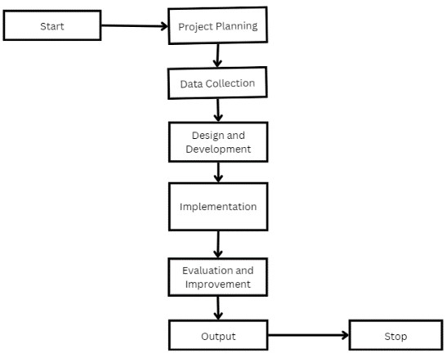

Fig.3.1 Flowchart

**1. Project Planning and Requirement Analysis:**

* Define the scope and objectives of the chatbot.
* Identify the target audience and use cases.
* Gather requirements and set project milestones.

* 1. **Data collection, Design and Development:**
* **Chatbot Architecture:** Design the architecture of the chatbot, including the front-end and back-end components.
* **API Integration:** Integrate external APIs (if needed) to extend the chatbot’s functionality.
* **User Interface:** Design and develop the user interface for the chatbot.

* 1. **Implementation:**
* **Development:** Code the chatbot using a suitable programming language and framework (e.g., Python with a chatbot framework).
* **Testing:** Conduct thorough testing to identify and fix bugs and ensure the chatbot operates as expected.
* **Deployment:** Deploy the chatbot on a suitable platform (e.g., web, mobile, or messaging apps).

* 1. **Evaluation and Improvement:**
* **User Feedback:** Collect feedback from users to assess the chatbot’s performance.
* **Iteration:** Make necessary improvements based on the feedback and performance metrics.

**CHAPTER 4**

# IMPLEMENTATION

## System Overview

The AI chatbot for the Department of AI & DS is designed to provide instant and accurate responses to user inquiries related to the department. The system consists of a Flask-based backend server that interfaces with Google Generative AI for natural language processing and a frontend web application that allows users to interact with the chatbot.

➢ **Frontend Implementation**

The frontend of the chatbot is built using HTML, CSS, and JavaScript. It provides a user interface for interacting with the chatbot.

• **HTML Structure**

The HTML file sets up the layout for the chatbot interface:

<!DOCTYPE html>

<html lang="en">

<head>

<meta charset="UTF-8">

<meta name="viewport" content="width=device-width, initial-scale=1.0">

<title>KSSEM</title>

<link rel="stylesheet" href="style.css">

</head>

<body>

<div class="chat-container">

<div class="chat-header">

<h1>Department of AI & DS</h1>

</div>

<div class="chat-box" id="chat-box"></div>

<input type="text" id="user-input" placeholder="Type a message...">

<button onclick="sendMessage()">Send</button>

</div>

<script src="script.js"></script>

</body>

</html>

• **CSS Styling**

The CSS file styles the chatbot interface, ensuring it is visually appealing and userfriendly:

CSS body { font-family: Arial, sans-serif; display: flex; justify-content: center; align-items: center; height: 100vh; background: linear-gradient (to right, #0056a3, #7ed6df); margin: 0;

}

. chat-container { background-color: #f5f5f5; width: 500px; box-shadow: 0 8px 16px rgba(0, 0, 0, 0.2); border-radius: 12px; overflow: hidden;

}

. chat-box { height: 450px; overflow-y: auto; padding: 16px; border-bottom: 1px solid #ddd;

}

. chat-message {

text-align: left; margin-bottom: 16px; line-height: 1.4; padding: 8px 12px; border-radius: 12px; max-width: 80%; display: inline-block; word-wrap: break-word; }

.user-message {

text-align: right; color: #fff; background-color: #3d8dd3; align-self: flex-end; }

. bot-message {

text-align: left; color: #fff; background-color: #56ca3e; align-self: flex-start; } . input-container { display: flex; border-top: 1px solid #ddd; padding: 8px; } . chat-header h1 { font-size: 32px; color: #2c89e0; margin-bottom: 10px; display: flex; align-items: center; justify-content: center; } input[type="text"] { width: calc (100% - 25px); padding: 12px; border: none;

outline: none; font-size: 14px; border-radius: 12px; box-shadow: inset 0 1px 3px rgba(0, 0, 0, 0.1); transition: background-color 0.3s;

} input[type="text"]: focus { background-color: #e0e0e0;

} button { width: 80px; padding: 16px; border: none; background-color: #3585cb; color: white; cursor: pointer; border-radius: 12px; transition: background-color 0.3s, transform 0.3s;

}

Button: hover { background-color: #3585cb; transform: scale (1.05);

}

• **JavaScript Functionality**

The JavaScript file handles user interactions and communication with the backend:

function appendMessage(text, className) { const chatBox = document.getElementById('chat-box'); const messageElement = document.createElement('div'); messageElement.className = chat-message ${className}; messageElement.textContent = text; chatBox.appendChild(messageElement); chatBox.scrollTop = chatBox.scrollHeight;

}

async function sendMessage() { const userInput = document.getElementById('user-input'); const message = userInput.value; if (message.trim() === '') return; appendMessage(You: ${message}, 'user-message'); userInput.value = ''; const response = await fetch('http://127.0.0.1:5000/chat', { method: 'POST', headers: { 'Content-Type': 'application/json' }, body: JSON.stringify({ message: message })

});

const data = await response.json(); appendMessage(AI&DS Chatbot: ${data.response}, 'bot-message'); }

➢ **Backend Implementation**

• **Flask Server Setup**

The backend is developed using Flask, a lightweight web framework for Python. The server handles incoming chat requests, processes them using the Google Generative AI model, and returns the responses to the frontend.

from flask import Flask, request, jsonify from flask_cors import CORS import google.generativeai as genai app = Flask(_name_)

CORS(app) # This will enable CORS for all routes **Configure Google Generative AI:**

GOOGLE_API_KEY = "GEMENI_API_KEY" genai.configure(api_key=GOOGLE_API_KEY) model = genai.GenerativeModel('gemini-pro') **Define Chat Function:** def chat_with_gemini(text): kb = """

Database(knowledge base)

response = model.generate_content(content) response.resolve() return response.text **Create Chat Route:**

@app.route('/chat', methods=['POST']) def chat ():

user_input = request.json.get("message") response_text = chat_with_gemini(user_input) return jsonify({"response": response_text}) if _name_ == '_main_': app.run(debug=True)

**CHAPTER 5**

# RESULTS

The results chapter presents the findings and outcomes of the AI chatbot project for the Department of AI & DS at KS School of Engineering and Management. The primary goal of this project was to create a chatbot capable of providing accurate and immediate information about the department, enhancing user engagement and operational efficiency.

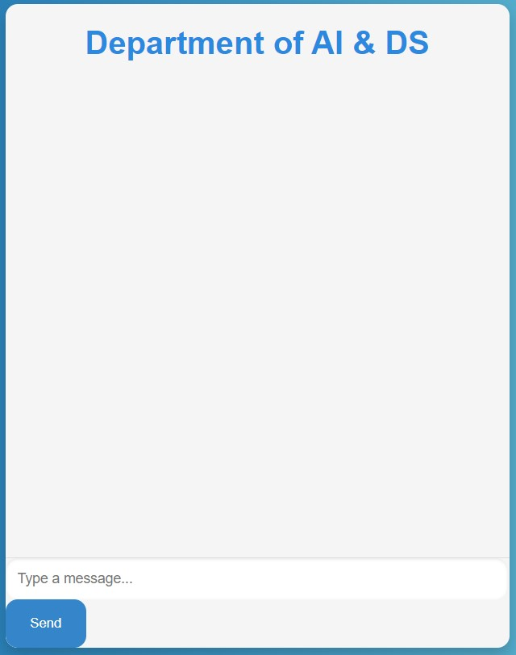

Fig.5.1 Department Chatbot

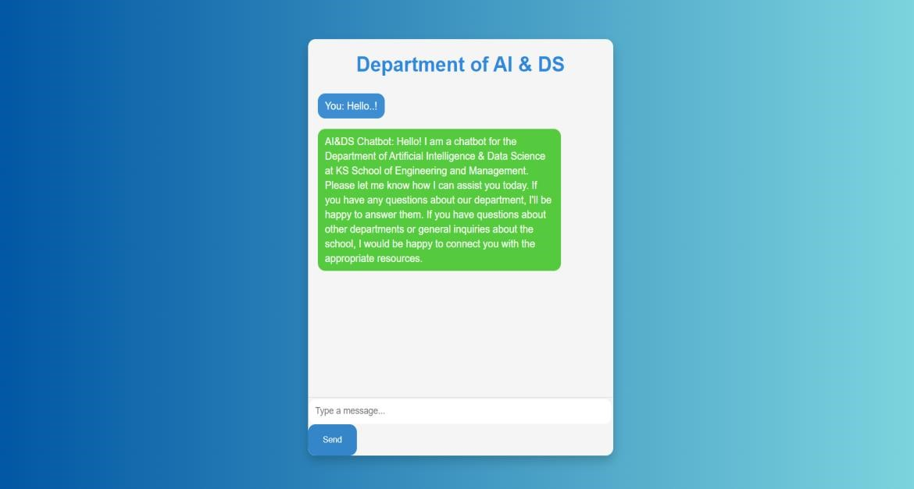

Fig.5.2 Reply for the query

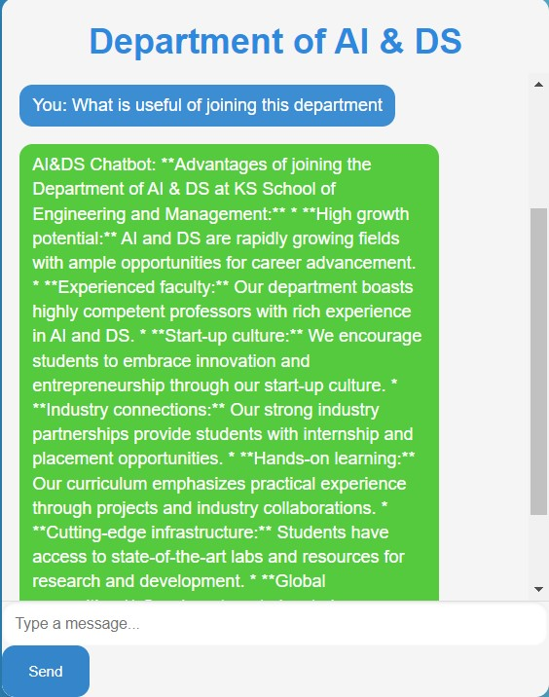

Fig.5.3 What is useful of joining this department

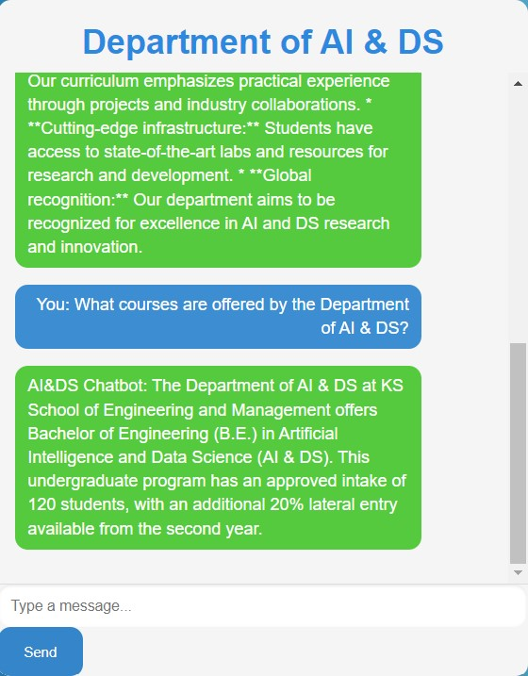

Fig.5.4 What are the courses offered by the Department of AI&DS

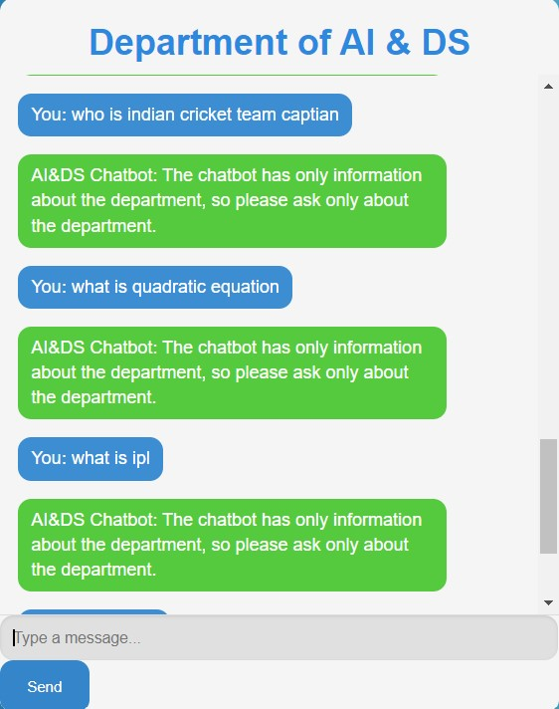

Fig.5.5 Chatbot responding for other questions other than department related

**CHAPTER 6**

# DISCUSSION

## Interpretation of Results

The AI chatbot for the Department of AI&DS at KS School of Engineering and Management was successfully implemented and tested. The chatbot could handle various user queries related to the department, such as faculties information, workshops, vision, mission event schedules and information related to the department.. The results demonstrate the chatbot's effectiveness in providing instant and accurate information, thereby enhancing user engagement and operational efficiency.

**User Engagement:** The chatbot provided immediate responses, significantly improving user interaction with the department's website.

**Accuracy:** The chatbot accurately addressed a wide range of queries, showcasing the robustness of the knowledge base and the generative AI model.

**Operational Efficiency:** By handling routine inquiries, the chatbot reduced the workload on administrative staff, allowing them to focus on more complex tasks.

## Comparison with Objectives

The chatbot was successfully developed using Flask, Google Generative AI, and integrated into the department's website.

The chatbot handled various types of queries effectively, demonstrating a comprehensive understanding of the knowledge base.

Improve user engagement and satisfaction by providing instant and accurate information.

User feedback indicated higher engagement and satisfaction levels due to the instant and accurate responses provided by the chatbot.

Enhance operational efficiency by reducing the workload on administrative staff. The chatbot successfully handled routine inquiries, freeing up administrative staff to focus on more complex and value-added tasks.

## Discrepancies and Areas for Improvement

While the chatbot met most of the objectives, there were some discrepancies and areas for further improvement.

* **Continuous Learning and Adaptation**

Observation: The chatbot's performance is limited to the static knowledge base and predefined responses.

Recommendation: Implementing a feedback loop for continuous learning and adaptation can improve the chatbot’s accuracy and relevance over time. ➢ **User Interface Enhancements:**

Observation: While the chatbot interface was functional, user feedback suggested improvements in the visual design and user experience.

Recommendation: Further refinement of the user interface and user experience design can enhance overall user satisfaction.

* **Language Support:**

Observation: The chatbot currently supports only English, limiting accessibility for nonEnglish speaking users.

Recommendation: Incorporating multi-language support can broaden the chatbot’s usability and inclusivity.

* **Handling Highly Specific Queries:**

Observation: The chatbot struggled with highly specific or unusual queries that were not covered in the predefined knowledge base.

Recommendation: Expanding the knowledge base and incorporating advanced natural language processing (NLP) techniques can help the chatbot handle a broader range of queries.

# CONCLUSION

## Key Findings

1. **Enhanced User Engagement:** The AI chatbot for the Department of AI & DS at KS School of Engineering and Management significantly improved user engagement by providing instant and accurate responses to user inquiries.
2. **Operational Efficiency:** The automated responses to frequently asked questions ensured that users received timely assistance without the need for human intervention.
3. **Technical Performance:** The integration of the Google Generative AI model with the Flask framework proved successful. The chatbot demonstrated a robust ability to understand and generate relevant responses based on the knowledge base, highlighting the effectiveness of the chosen methodologies.
4. **Scalability and Flexibility:** The chatbot was designed with scalability in mind, allowing for future expansions of its knowledge base and capabilities. The modular design ensures that new features and improvements can be easily integrated.

## Implications

1. **Improved Information Accessibility:** The chatbot has made departmental information more accessible to students and visitors. This improvement in accessibility is likely to enhance overall engagement with the department and foster a better understanding of its offerings and activities.
2. **Potential for Wider Adoption:** The success of the chatbot in the Department of AI & DS suggests that similar solutions could be implemented across other departments and institutions. This could lead to a broader adoption of AI chatbots in educational settings, enhancing information dissemination and user engagement on a larger scale.
3. **Resource Optimization:** By automating routine queries, the chatbot allows human resources to be allocated more efficiently. Administrative staff can now focus on tasks that require human judgment and expertise, leading to better resource utilization.

## Potential Future Work

1. **Expanding the Knowledge Base:** Future work could focus on expanding the chatbot’s knowledge base to cover more specific and detailed information. This could include integrating academic resources, faculty research interests, and detailed course descriptions.
2. **Multilingual Support:** Adding multilingual support would make the chatbot accessible to a more diverse user base, including international students and visitors. This could involve incorporating natural language processing (NLP) capabilities for multiple languages.
3. **Integration with Other Systems:** Integrating the chatbot with other systems, such as student information systems and learning management systems, could provide more personalized and context-aware responses. This could enhance the chatbot’s utility and relevance to individual users.
4. **Continuous Improvement through User Feedback:** Implementing mechanisms to collect and analyze user feedback continuously could help refine the chatbot’s performance. Regular updates based on user interactions and feedback would ensure that the chatbot remains relevant and effective.
5. **Voice Interaction:** Developing a voice interaction capability would make the chatbot more accessible and user-friendly, particularly for users who prefer verbal communication over text.

By building on these key findings and exploring the potential future work, the AI chatbot project can continue to evolve and provide even greater value to the Department of AI&DS and its stakeholders. The ongoing development and enhancement of the chatbot will ensure that it remains a vital tool for information dissemination and user engagement in the educational environment.

Overall, the AI chatbot project achieved its primary objectives, significantly improving user engagement and operational efficiency for the Department of AI&DS at K S School of Engineering and Management.

With continuous improvement and adaptation, the chatbot has the potential to become an even more integral part of the department's digital infrastructure, offering enhanced support and accessibility to all users.

# REFERENCES

1. Varshini, S. K, Shilpa Shri, R, & Anusha, U. A. (2024). Literature Survey on College Information Chatbot. International Journal of advanced research in science, communication and technology (IJARSCT), Volume:4, Issue:1.

1. Romao, G. M. dos S. (2021). A Literature Review on Chatbots in Education: An

Intelligent Chat Agent. Catholic University of Mozambique.

1. Mukherjee, S., & Patra, S. K. (2023). A Review of Their Potential Applications in

Library Services. Sidho-Kanho-Brisha university.

1. Caldarini, G., Jaf, S., & McGarry, K. (2022). A Literature Survey of Recent Advances in Chatbots. MDPI, The university of Sunderland, Faculty of Technology, Sunderland,

SRI 3SD, UK

1. Sanjaya, W., Calvin, Rafif M., Meiliana, & Fajar, M. (2023). Literature Review on Implementation of Chatbots for Commerce Use. International conference on computer science and computational Intelligence (ICCSCI 2023)

1. Calvaresi, D., Mualla, Y., & Schumacher, M. (2023). Exploring Agent-Based Chatbots: A Systematic Literature Review. Journal of Ambient Intelligence and

Humanized Computing (2023)

1. Gatzioufa, P., & Saprikis, V. (2022). A Literature Review on Users’ Behavioural Intention Toward Chatbots’ Adoption. Department of Management Science and

Technology, School of Economic Sciences.

1. Pillare, T., Dudhe, P., Chinte, S., & Ade, S. (2023). A Survey Paper on Chatbot. International Research Journal of Modernization in Engineering Technology and

Science, Volume:05, Issue:10.

1. Oh, Y. J., Zhang, J., & Fukuoka, Y. (2021). A Systematic Review of Artificial Intelligence Chatbots for Promoting Physical Activity, Healthy Diet, and Weight Loss.

International Journal of Behavioural Nutrition and Physical Activity.

1. Meshram, S., Naik, N., VR, M., & More, T. (2021). Conversational AI: Chatbot.

IEEE.

# APPENDICES

The appendices section provides supplementary materials that support the main body of the report. This includes raw data, additional graphs, and alternative code samples that were part of the development process for the AI Chatbot for the Department of AI & DS at KS School of Engineering and Management. These materials are included to offer a comprehensive view of the project's scope and technical implementation.

## Raw Data

* **Example Queries and Responses:**
  + **Query:** "What courses are offered by the Department of AI & DS?" o **Response:** "The Department of AI & DS offers courses such as Introduction to AI, Machine Learning, Data Science, and Deep Learning."
  + **Query:** "How can I apply for admission?" o **Response:** "You can apply for admission through the college's official website. Please visit the admissions section and follow the instructions provided."
* **User Feedback:**
  + **Positive Feedback:** "The chatbot quickly provided accurate information about the courses."
  + **Areas for Improvement:** "The chatbot struggled with very specific queries related to course prerequisites."

**Chatbot Interaction Flow:**

User Query --> Chatbot Processing --> Generative Model (Google Gemini) --> Response Generation --> User Response